ALFA TECH INDIA Online Milk Pasteurizer 500 LPH

Capacity | 500 L
Capacity(LPH) | 500
Voltage | 440v
Machine Body Material | Stainless Steel 304
Design Type | Customized, Standard
Phase | 3 Phase
Automation Grade | Automatic
Power | Electrical
Power Source | 440 V
Power Supply | Electrical
Design | Customized
Cooling Temp. | 4Deg c
Finishing | High Quality Product
Weight | 500 KG
Frequency | 50Hz
Product Type | Fully Automatic
Heater Power | 80 Deg C
Motor Horsepower | 1 Hp
Temperature | Temperature Range : 4-42-65-72- 80/80-15-4 deg C
Shape | Customized
Material Grade | SS 304
Material | Stainless Steel
I Deal In | New Only
Brand | 3i Tech
Balance Tank | 50 LTR
Milk Pump | 1 Hp
Hot water Pump | 1 Hp Crompton Make
Chilled Water Pump | 1 Hp Crompton Make
Control Panel | Control Panel with Temperature indicators
Country of Origin | Made in India

Alfa Tech India Online Milk Pasteurizer 500LPH

Technical Parameters of Product:
: Whole Milk Temperature range : 4-42-65-72-80/80-15-4 deg C1. Duty 1
: Milk Pasteurization @ 80degC and Outlet @ 4 DegC Holding Time
: 16 Sect is complete with:• Balance Tank: 50 lit.• Inline Filter
: 1 Quantity• Milk Pump : 1 HP• Holding Tube• Hot water System complete with Hot Water Battery, Hot water Pump 1 Hp
: Crompton make ,Chilled Water Pump 1 Hp
:Crompton make• Control Panel with Temperature indicators• SS Pipes, valves & Fittings• Skid mounted PLATE PACK

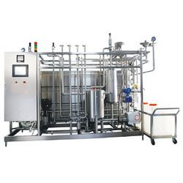
SKIED MOUNTED PASTURISER PLANT:
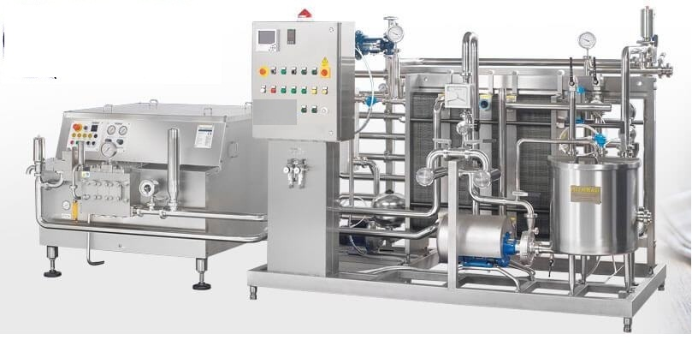
Skid-mounted Milk Pasteurizer with Homogenizer
Capacity : 300 LPH
Heating Method: plate heat exchanger
Temperature Range: Pre-heat: 45°C to 60°C
Pasteurization: 72°C to 75°C (for 15-20 seconds)
Cooling Method: Forced cooling using a plate heat exchanger or cooling water jacket
Sanitization: CIP (Clean-in-Place) cleaning system for hygiene.
Homogenizer Section:
Capacity: 300 L/hrs. at 1-5 MPa pressure
Homogenizing Pressure : 100-200 bar (10-20 MPa)
Homogenizing Valves, Piston Type
Power Supply: 3-phase, 50 Hz, 380-415 V
Control Panel : easy operation and monitoring
Stainless Steel: 304 grade for all product-contact surfaces
Gaskets and Seals: Food-grade silicone or EPDM gaskets
